**Front-End UI/UX Mini Project**

**1. Title Page**

* **Project Title**: E-Learning Course Overview Page
* **Submitted By**: 
  + *Team Members-*

*Karthik Rajeev (2462096)*

Levin Thomas (2462517)

Pagadala Rohith (2462523)

* + *College-E-mail id-*

[*karthik.rajeev@btech.christuniversity.in*](mailto:karthik.rajeev@btech.christuniversity.in)

[*levin.thomas@btech,christuniversity.in*](mailto:levin.thomas@btech,christuniversity.in)

[*pagadala.rohith@btech.christuniversity.in*](mailto:pagadala.rohith@btech.christuniversity.in)

* **Course**: *UI/UX Design Fundamentals*
* **Instructor Name**: *Nagaveena.*
* **Institution**: *Christ University*
* **Date of Submission**: *12/08/2025*

**2. Abstract**

This project focuses on designing and developing a responsive e-learning course overview page using HTML and CSS.

The goal was to create a visually engaging, mobile-friendly landing page that presents course details, instructor information, modules, student reviews, and enrollment options in an organized manner.

The design adopts a coral theme, combining a modern color palette with clean typography for improved readability. Core technologies include HTML5 for structure and CSS3 for styling, with Flexbox and Grid for layout management. The outcome is a professional, responsive course page suitable for educational platforms, enhancing user trust and encouraging enrollments

**3. Objectives**

* Design a visually appealing and user-friendly interface for an online course overview.
* Implement a fully responsive layout adaptable to desktop, tablet, and mobile devices.
* Use semantic HTML5 elements for clear content structure.
* Apply CSS3 for theme styling, layout control, and responsiveness.
* Maintain accessibility, readability, and consistent branding.

**4. Scope of the Project**

* Focused solely on front-end design (no JavaScript or backend functionality).
* Optimized for desktop, tablet, and mobile viewports.
* Pure HTML5 and CSS3 code — no external frameworks like Bootstrap.
* Target audience: potential students exploring e-learning courses.
* Includes course hero section, description, module list, instructor bio, reviews, and enrollment details.

**5. Tools & Technologies Used**

|  |  |
| --- | --- |
| Tool/Technology | Purpose |
| HTML5 | Markup and content structure |
| CSS3 | Styling and layout management |
| VS Code | Code editor |
| Chrome DevTools | Testing and debugging |

**6. HTML Structure Overview**

* Used semantic tags: <header>, <nav>, <main>, <section>, <footer>
* Structured into reusable sections: About, Projects, Contact
* Navigation menu using <ul> and anchor links for smooth scrolling

**7. CSS Styling Strategy**

* Used external CSS file (style.css)
* Organized with comments and sections
* Techniques used:
  + Flexbox and Grid for layout
  + Media Queries for responsiveness
  + CSS Variables for theme customization
  + Hover effects and transitions
  + Mobile-first design approach

**8. Key Features**

|  |  |
| --- | --- |
| Feature | Description |
| Responsive Design | Adapts seamlessly to all screen sizes |
| Smooth Navigation | Fixed top nav with anchor links |
| Project Cards | Flex-based layout with hover effects |
| Contact Form (non-functional) | Placeholder layout for inputs and button |
| Accessible Fonts & Colors | High contrast and readable typography |

**9. Challenges Faced & Solutions**

|  |  |
| --- | --- |
| Challenge | Solution |
| |  | | --- | | **Overlapping sections in course hero on small screens** |  |  | | --- | |  | | |  | | --- | |  |  |  | | --- | | Used **CSS media queries** to stack elements vertically | |
| Difficulty aligning course modules and badges | Implemented **Flexbox** and **CSS Grid** for proper alignment |
| Inconsistent typography across devices | |  | | --- | |  |  |  | | --- | | Applied **relative units** for scalable text | |

**10. Outcome**

* Achieved a clean, consistent, and visually engaging front-end layout
* All key components function as intended using just HTML and CSS
* Learned about layout responsiveness and UI hierarchy in depth

**11. Future Enhancements**

* Add JavaScript for interactivity (form validation, dynamic content)
* Integrate animations or transitions
* Backend integration for form submission
* Theme toggler (light/dark mode)

**12. Sample Code**

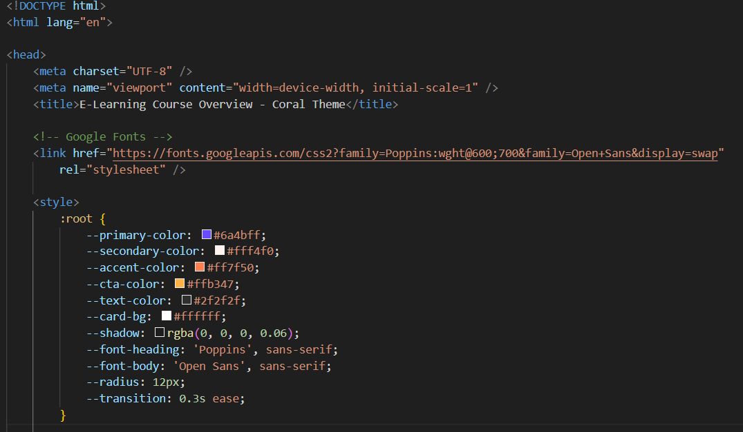

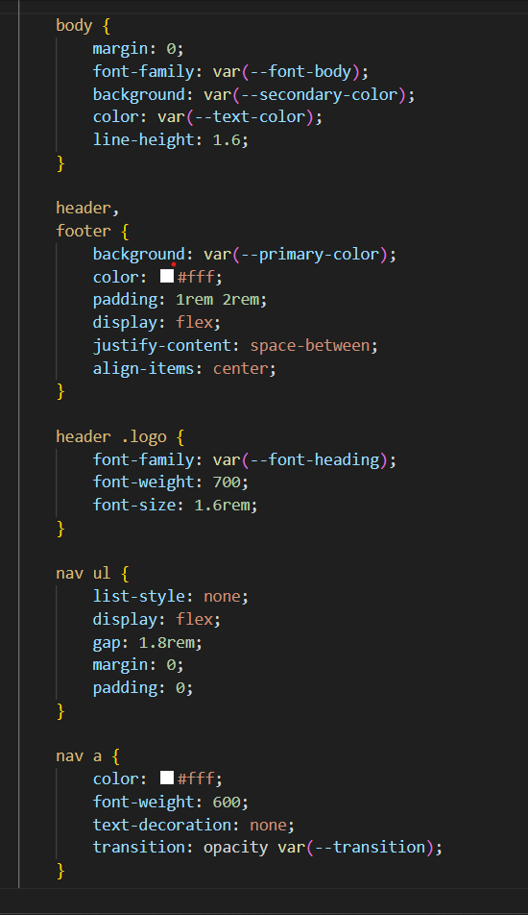

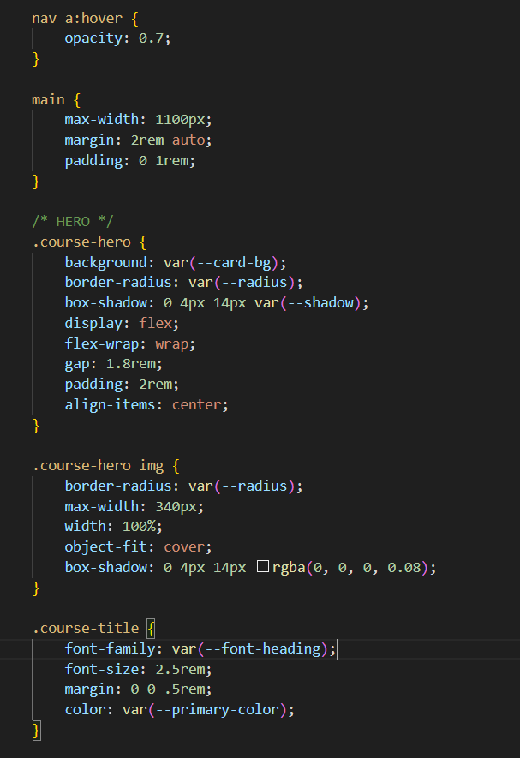

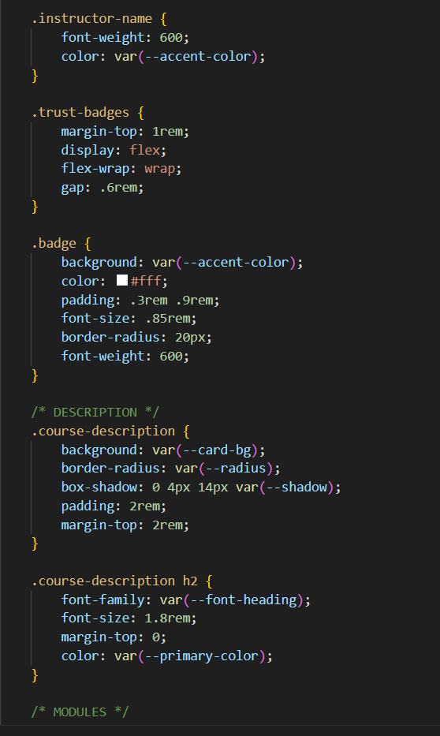

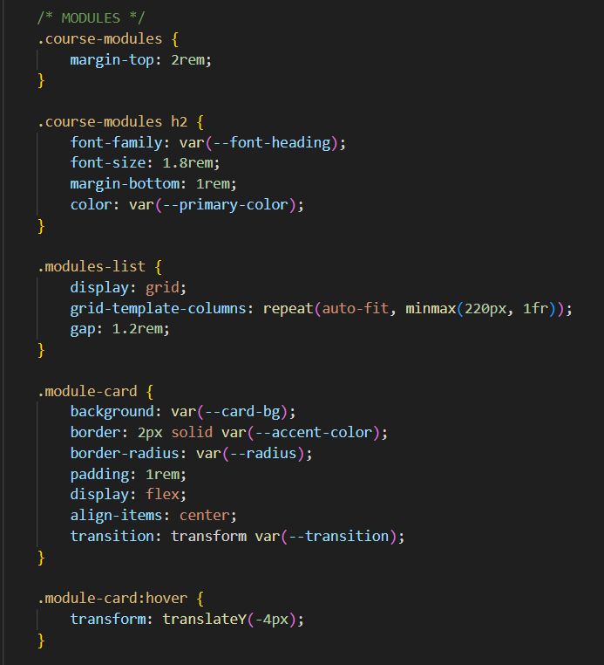

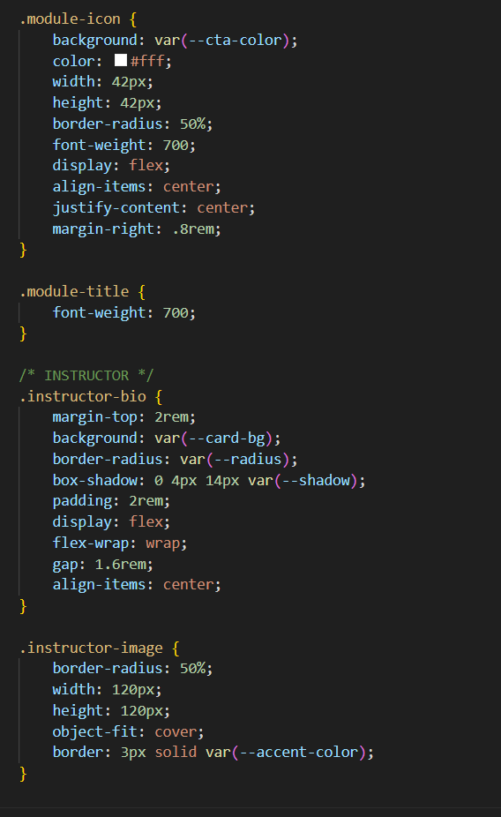

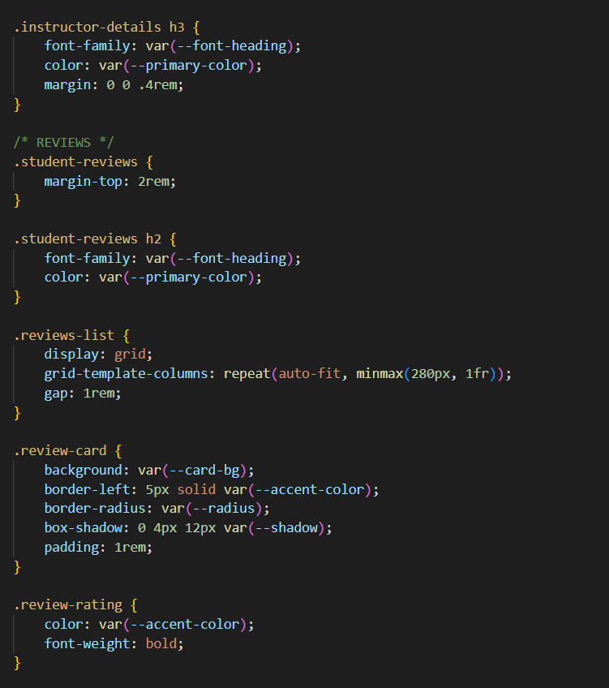

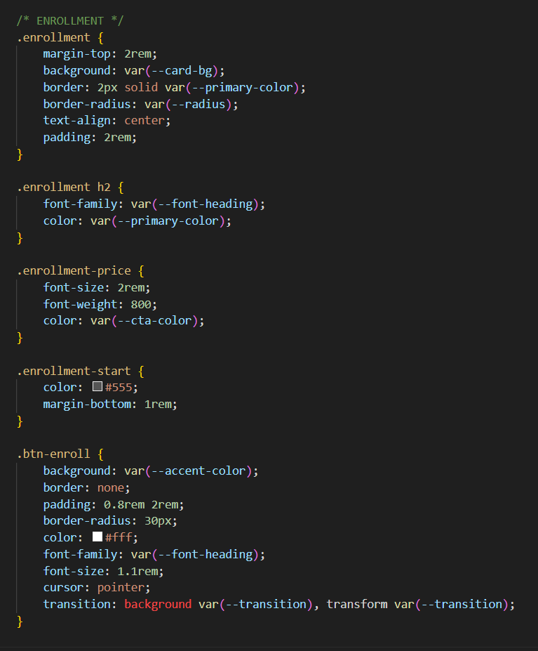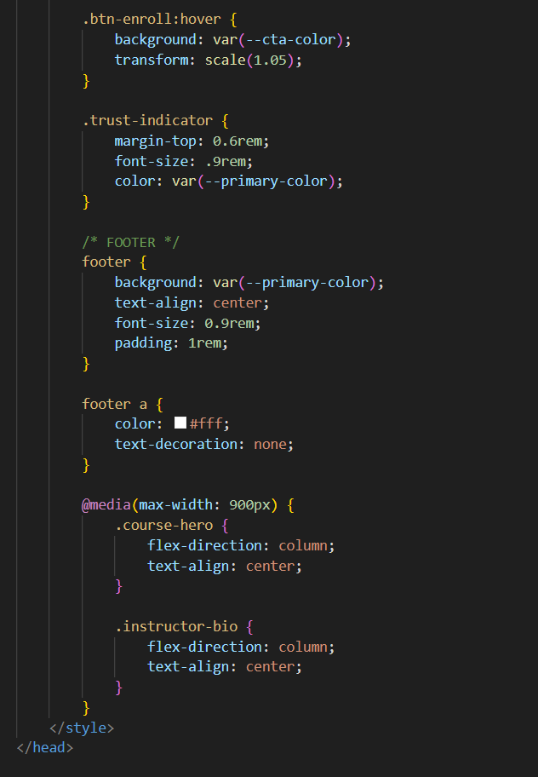

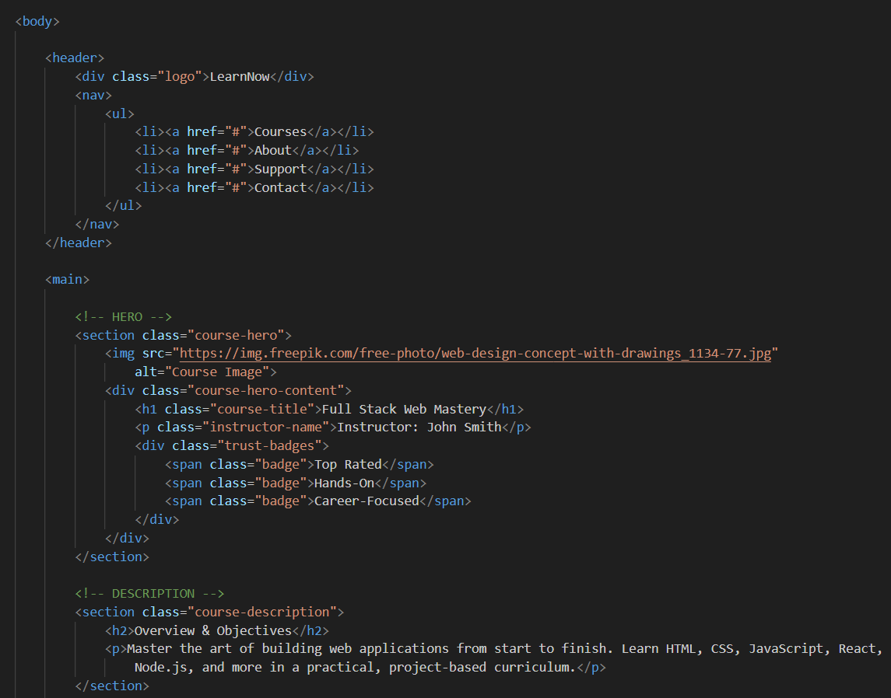

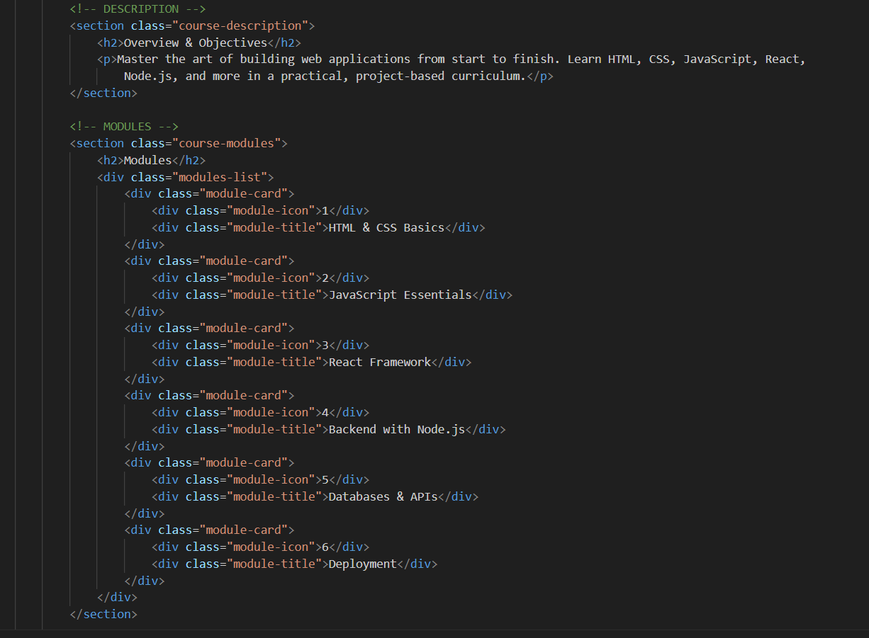

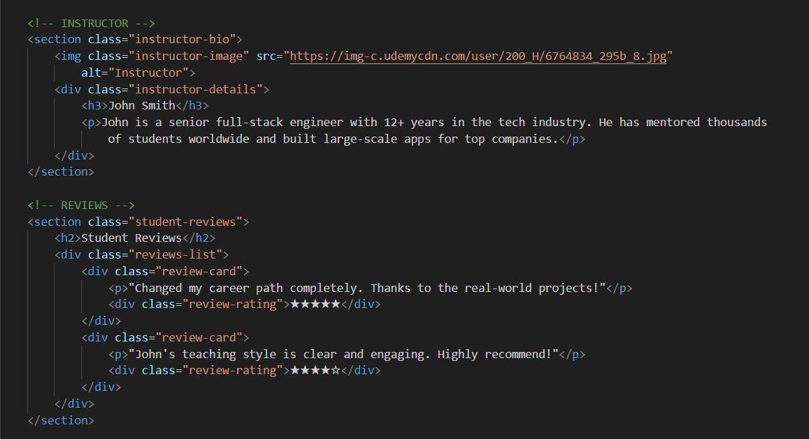

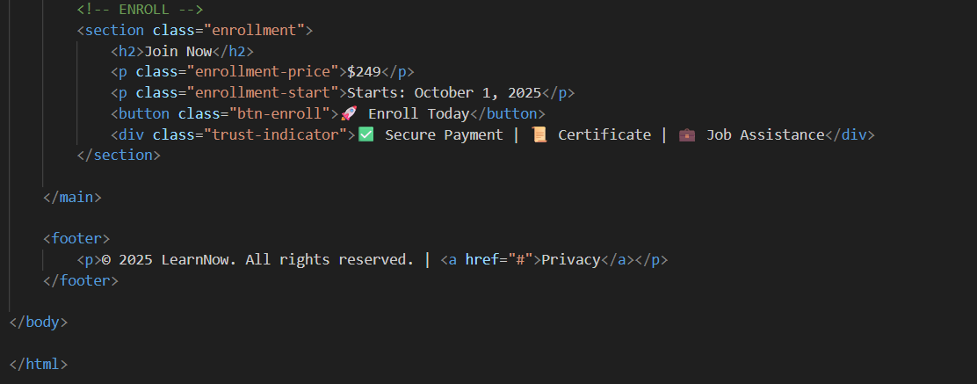

**13. Screenshots of Final Output**

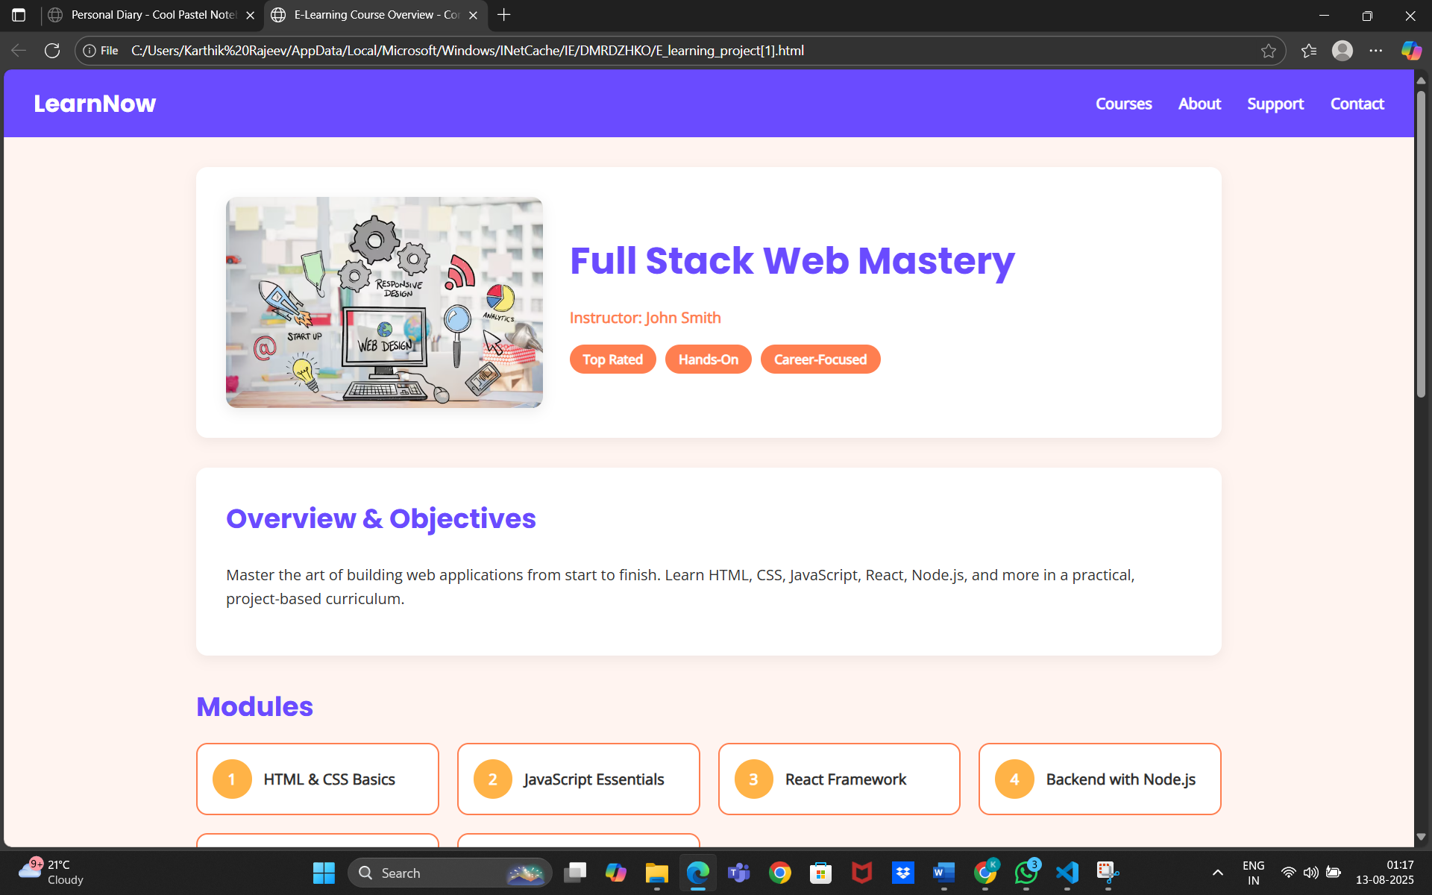

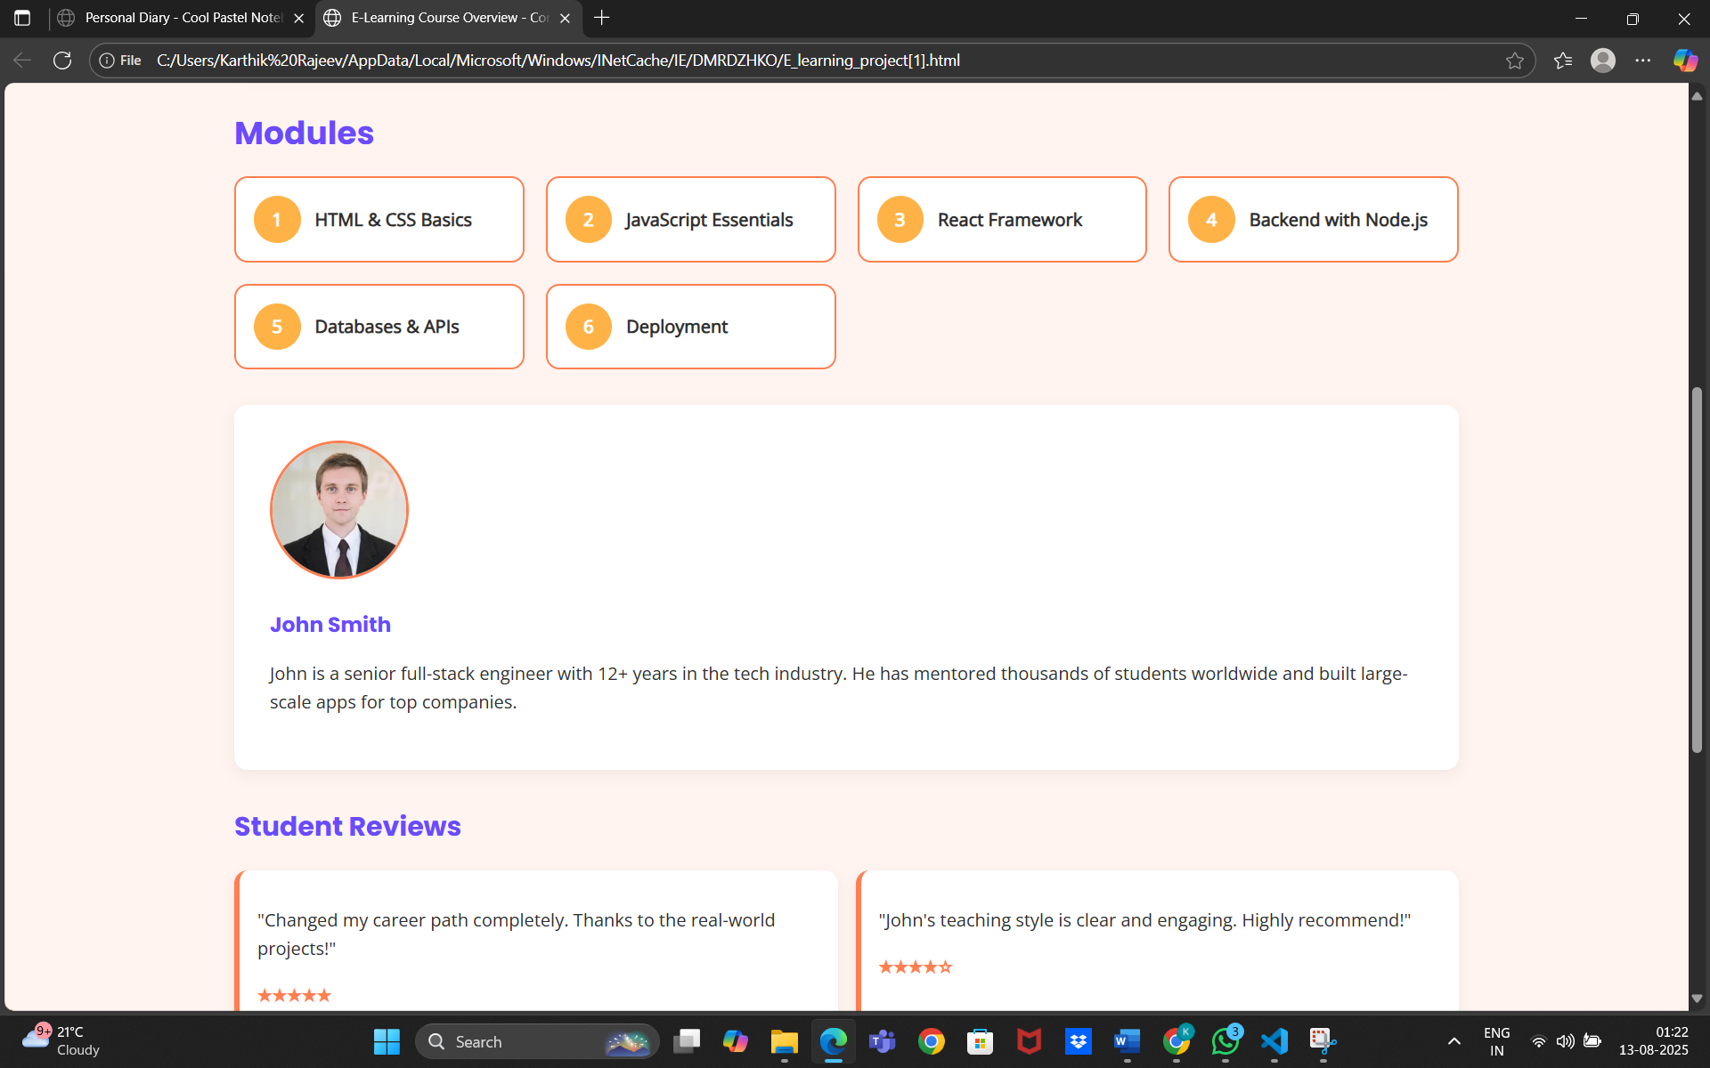

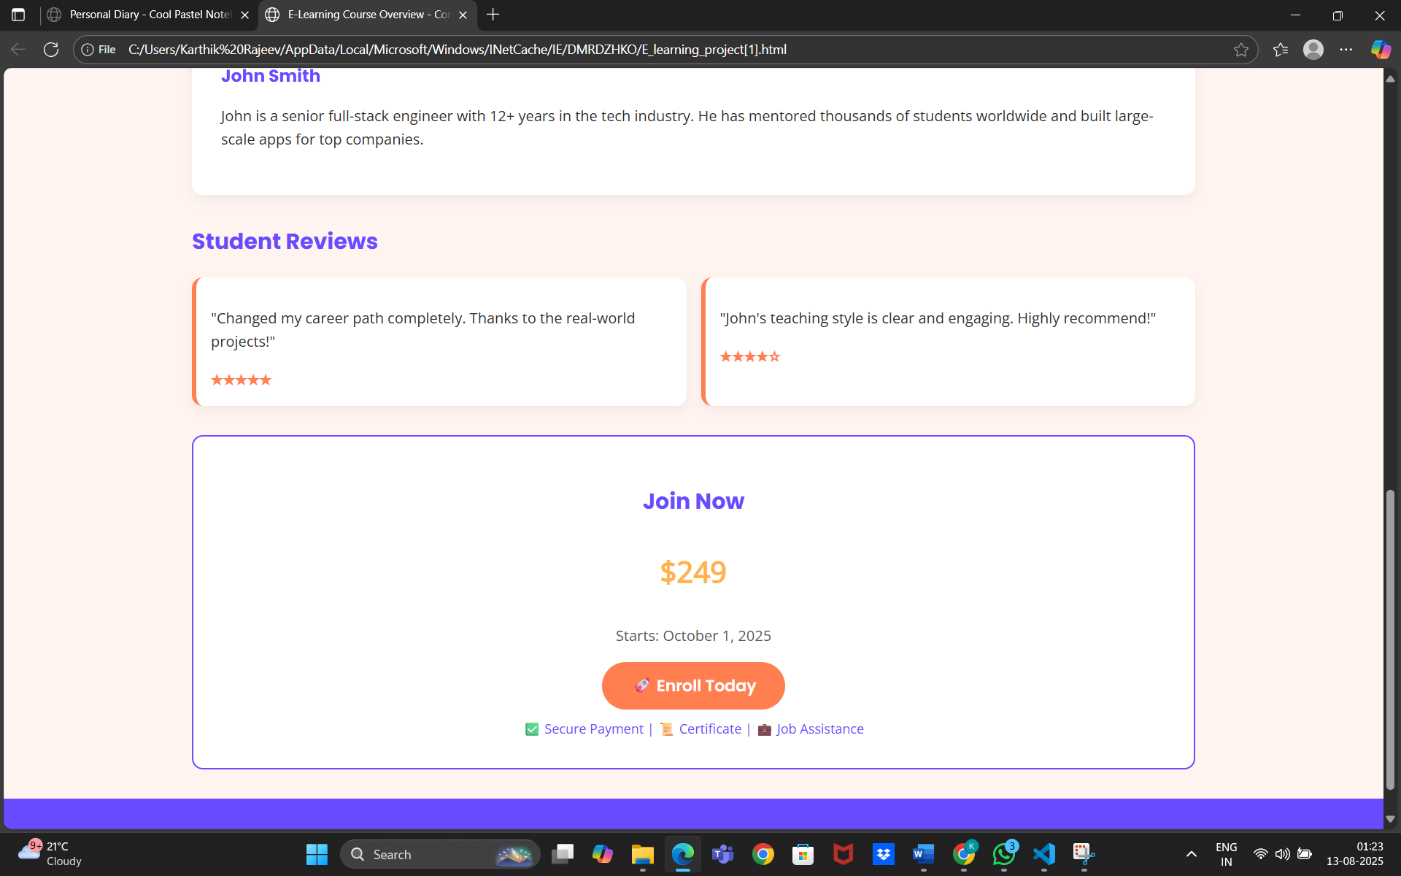

**14. Conclusion**

This E-Learning project provided an opportunity to design and develop a responsive, user-friendly learning platform interface using HTML and CSS. Through this work, I gained practical experience in structuring course layouts, organizing content for readability, and ensuring accessibility across different devices. The project strengthened my skills in responsive design, typography management, and layout techniques such as Flexbox and Grid. Overall, it enhanced my understanding of creating intuitive, visually appealing interfaces that support effective online learning experiences.

**15. References**

* L&T LMS: https://learn.lntedutech.com/Landing/MyCourse